What is a Padlet and How do I Use It?

**What is Padlet?**

Padlet is an interactive board that allows students to work collaboratively in the classroom. Teachers can post videos or questions on a Padlet board and students can respond to it. Students will be able to see each other’s responses in real time too.

**How Do I Use Padlet?**

1. First go to the Padlet webpage. The URL is <http://www.padlet.com>

2. Once you are on the site, you will need to sign up. Don’t worry it is free. Simply click on sign up.



3. Next, click on “NEW.” You will see this in the top right corner of your computer screen.



4. Choose the layout you’d like for your Padlet. Be sure to read the descriptions so you choose the correct one. My favorite is “Canvas” shown in green because it allows me to post things anywhere I want. There are many more than the ones shown here.

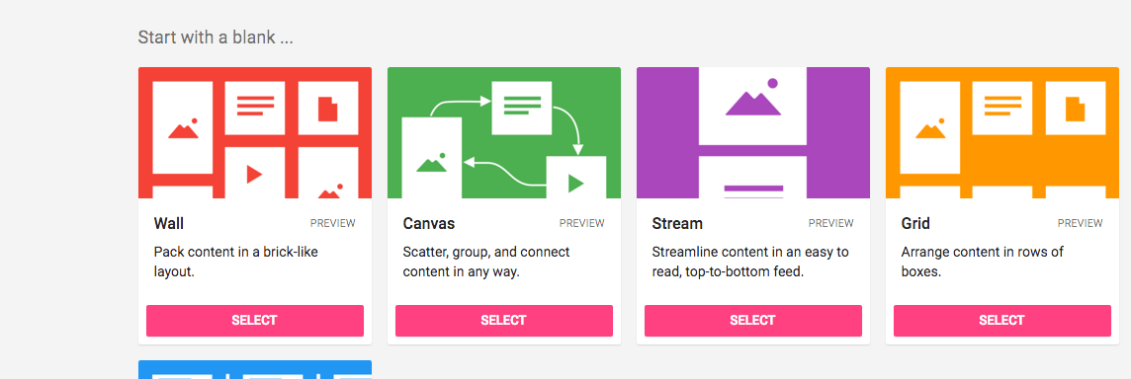

5. Once you do this, you will see your Padlet pop up. Don’t worry if you do not like the background. You will choose your own background using the side bar to the right. Click Next after you choose.

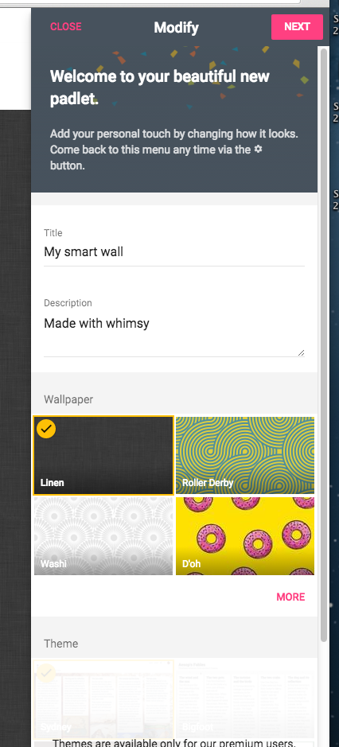

6. Once you have chosen your wallpaper, click on “Save” in the top right corner.

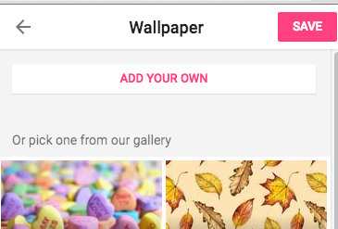

7. Now that you have saved your background, click on your blank Padlet screen. 

8. Next, you will double click on the Padlet wherever you want to add text, pictures, or videos.



8. You will notice that a popup box will appear. This is where you will have lots of options for adding things to your Padlet.

**1. Adding Text**

To add text, simply click on title and type in the title or focus for your text box. To type information, click on write something and type whatever you wish. Once you finish, you can click outside of the box to make the options go away. If you want to add pictures or video continue reading the directions that follow before clicking outside of the box. You do not have to have both a title and additional text. You can choose to do one or the other if you want.

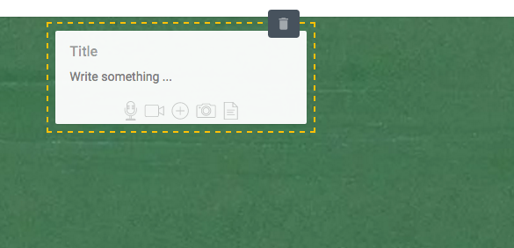

**2. Adding Video**

1. To add video start by clicking on the video camera icon in the popup box. Remember, to get the popup box you have to double click on your Padlet board.



2. If your video comes from Youtube or another site, type or paste the URL (web address) in the box shown on choice 1. Then click the arrow. If you are attaching an iMovie or file from your computer click on “choose a file” as shown on choice 2.

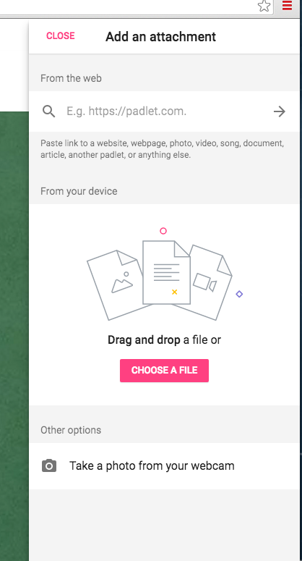 

**or**

3. Your video will pop up in the top right corner after you type in the URL or choose the file you want. If the correct video is shown, click on “OK.” The video will then be displayed on your Padlet.

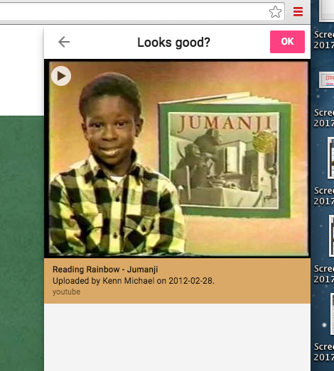

**3. Adding a Picture**

1. To add a picture start by clicking on the camera icon in the popup box. Remember, to get the popup box you have to double click on your Padlet board.



2. If your picture comes from image quest or another site, type or paste the URL (web address) in the box shown on choice 1. If you are attaching a picture that you saved to your computer click on “choose a file” as shown on choice 2.

 

**or**

3. Your picture will pop up in the top right corner after you type in the URL or choose the file you want. If the correct picture is shown, click on “OK.” The picture will then be displayed on your Padlet.

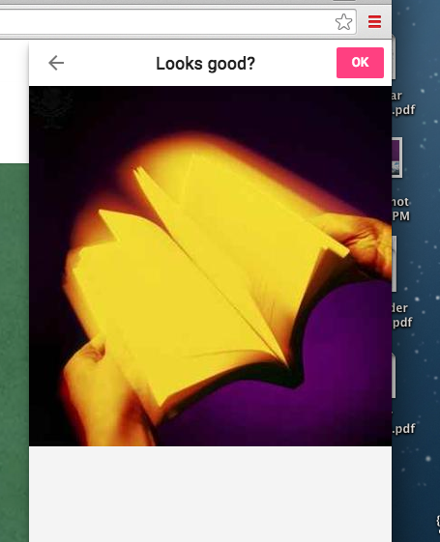

**4. Adding a URL**

1. Double click on your Padlet to get the popup box. Then click the addition sign.



2. Type of paste the URL into the box shown below and click the arrow.

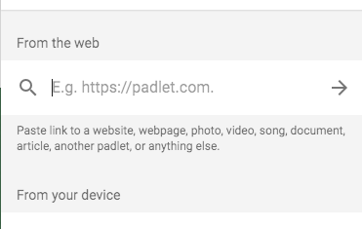

3. A picture associated with the site will pop up. If this looks correct, click on “OK.”

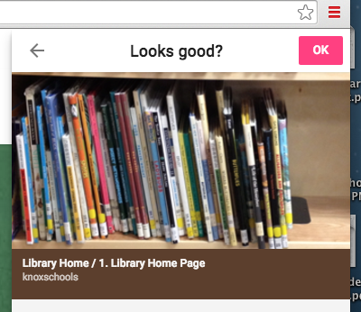

**Sharing your Padlet with Children.**

Click on “Share” in the top right corner.

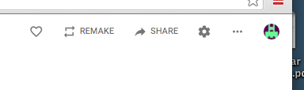

Decide who you want to see your Padlet and choose the option you like best. I usually use secret so only my students can see.

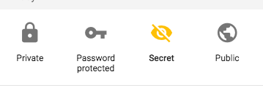

Now click on “share/export/embed” in the top right corner.

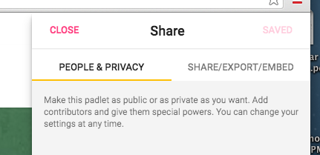

**A Few More Helpful Hints**

**1. Opening and editing a box:**

Place your mouse on the box and click the pencil. The box will open back up for editing.

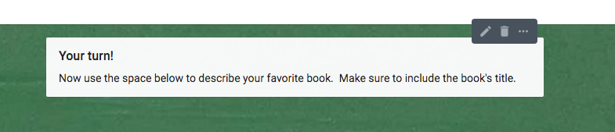

**2. Making your box bigger:**

Once your box is in edit mode using the directions above you will see a yellow line around your box. Put your mouse on the yellow line and you can stretch the box.

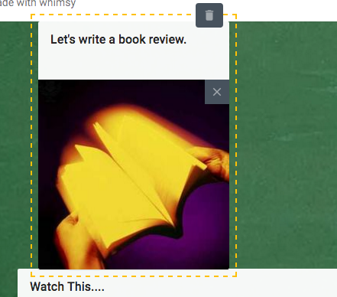

**Now you have a choice for getting your link.**

**Choice 1:** Click on copy link to this padlet. Now you can go ahead and put the link on a Word document, PowerPoint, website, or wherever you intend on your students seeing it.

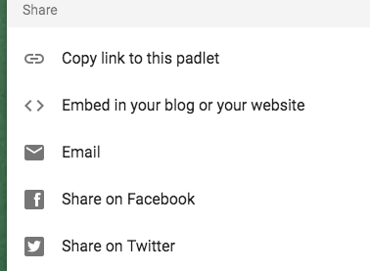

**Choice 2:** Copy and paste the URL directly from the address bar onto the document you wish for students to use to access the padlet.

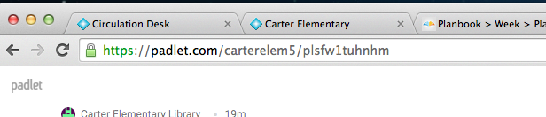

**Choice 3:**

Print off the CQ code and students can scan it from an iPad.

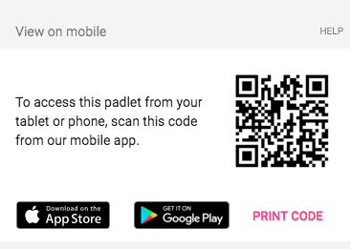

**Congratulations!**

You have now created your very own Padlet:

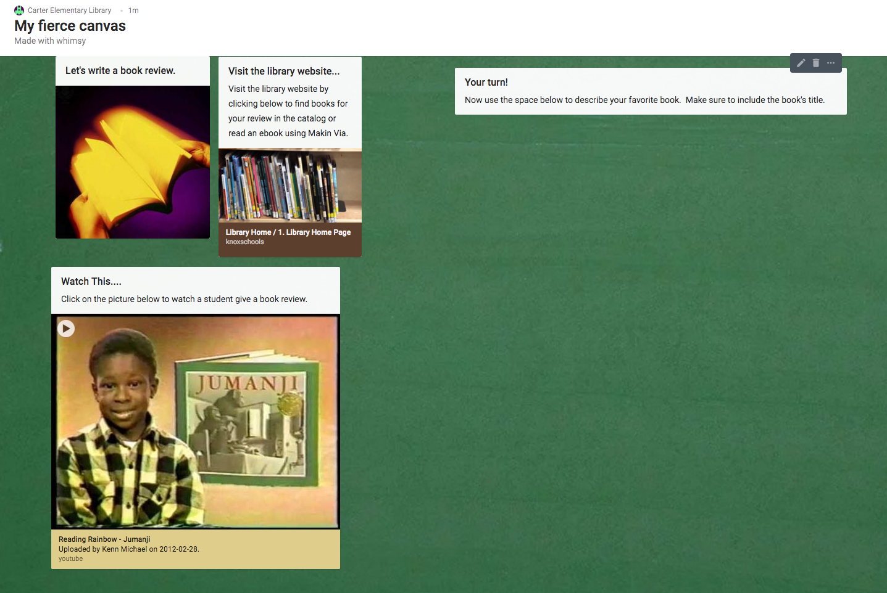

**Need More Help?**

Use the following links for videos that will give you additional information and more ideas on how to use Padlet.

<https://www.youtube.com/watch?v=UkBnwPqaIjA&t=182s>

<https://www.youtube.com/watch?v=f51WeQVLeVU>

<https://www.youtube.com/watch?v=5c9vWCPn8ys>

**More Examples :**

1. This one was Miss Cameron created for students to use in the Tech lab

<https://padlet.com/carterelem5/yf950ag53yyi>

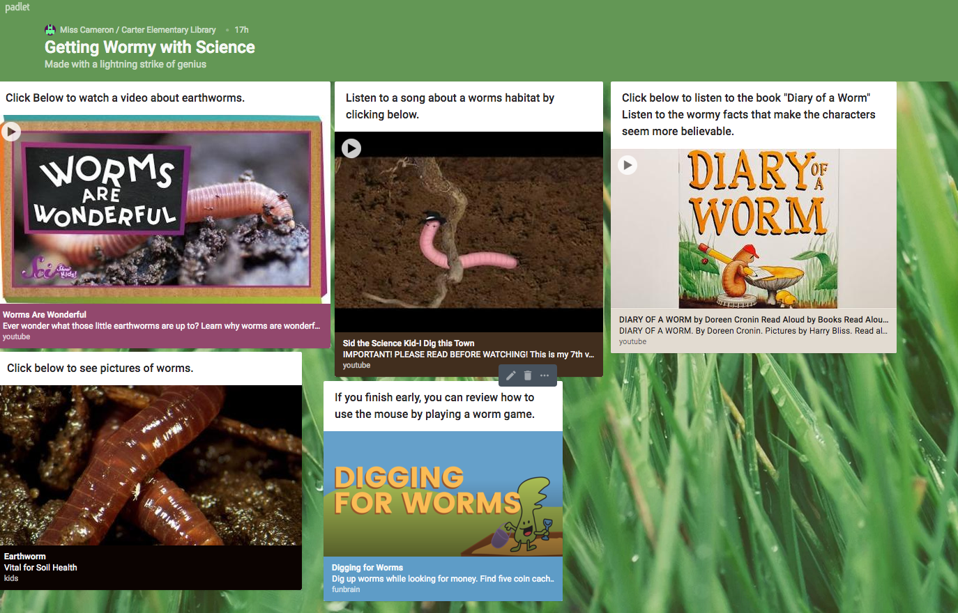

2. This is one that students created collaboratively in the library last year to post research:

[**https://padlet.com/carterelem5/6bsokpm9k344**](https://padlet.com/carterelem5/6bsokpm9k344)

